

**Reporting-2: System Design & Database Development & Data Dictionary**

Designed by:

1. **Jeet Gandhi**- - 1017

2. **Divy Rawal** - 1052

3. **Kavya Sevak** – 1062

4. **Prince Savaliya** - 1061

5. **Saiyam Shah** - 1064



**System Design**



**Design Layout ::**

**🡪** This is Our Home Page.





🡪Click the button consumer then open sign up page.

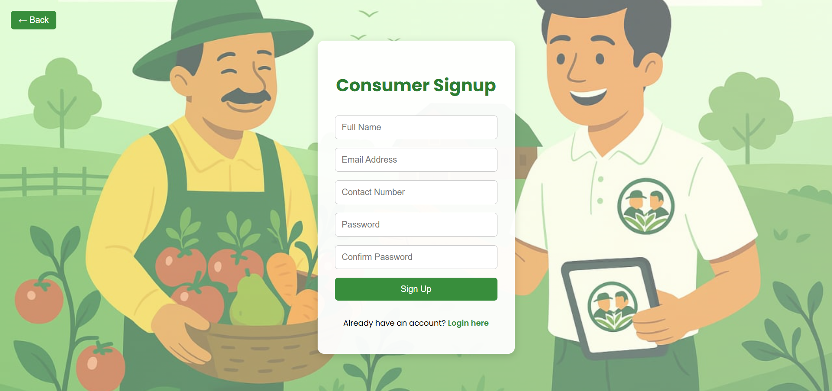



🡪Fill this all details in consumer page then will sign up.

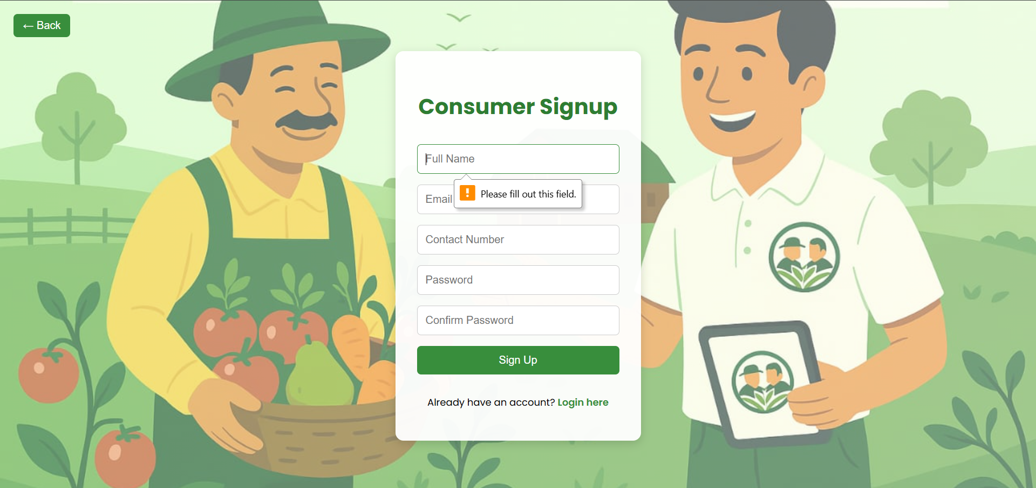



🡪 Fill up the details.

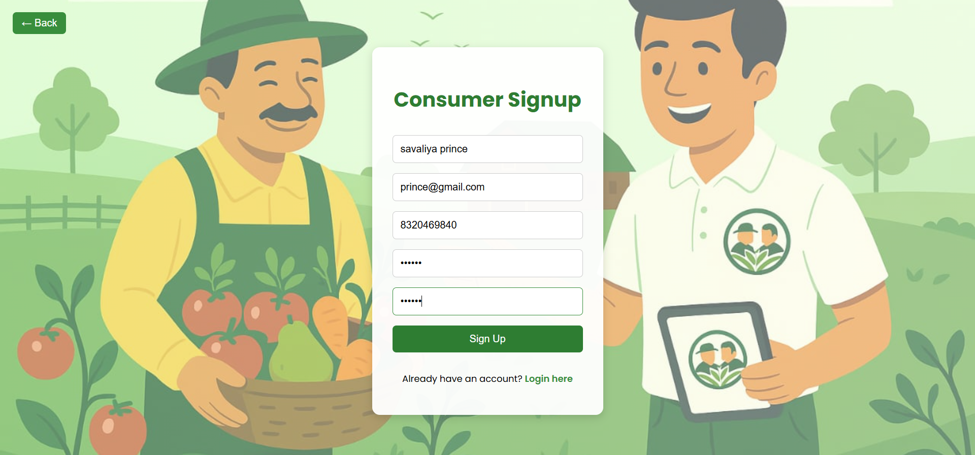



🡪 Fill up the all details then click sign up button.

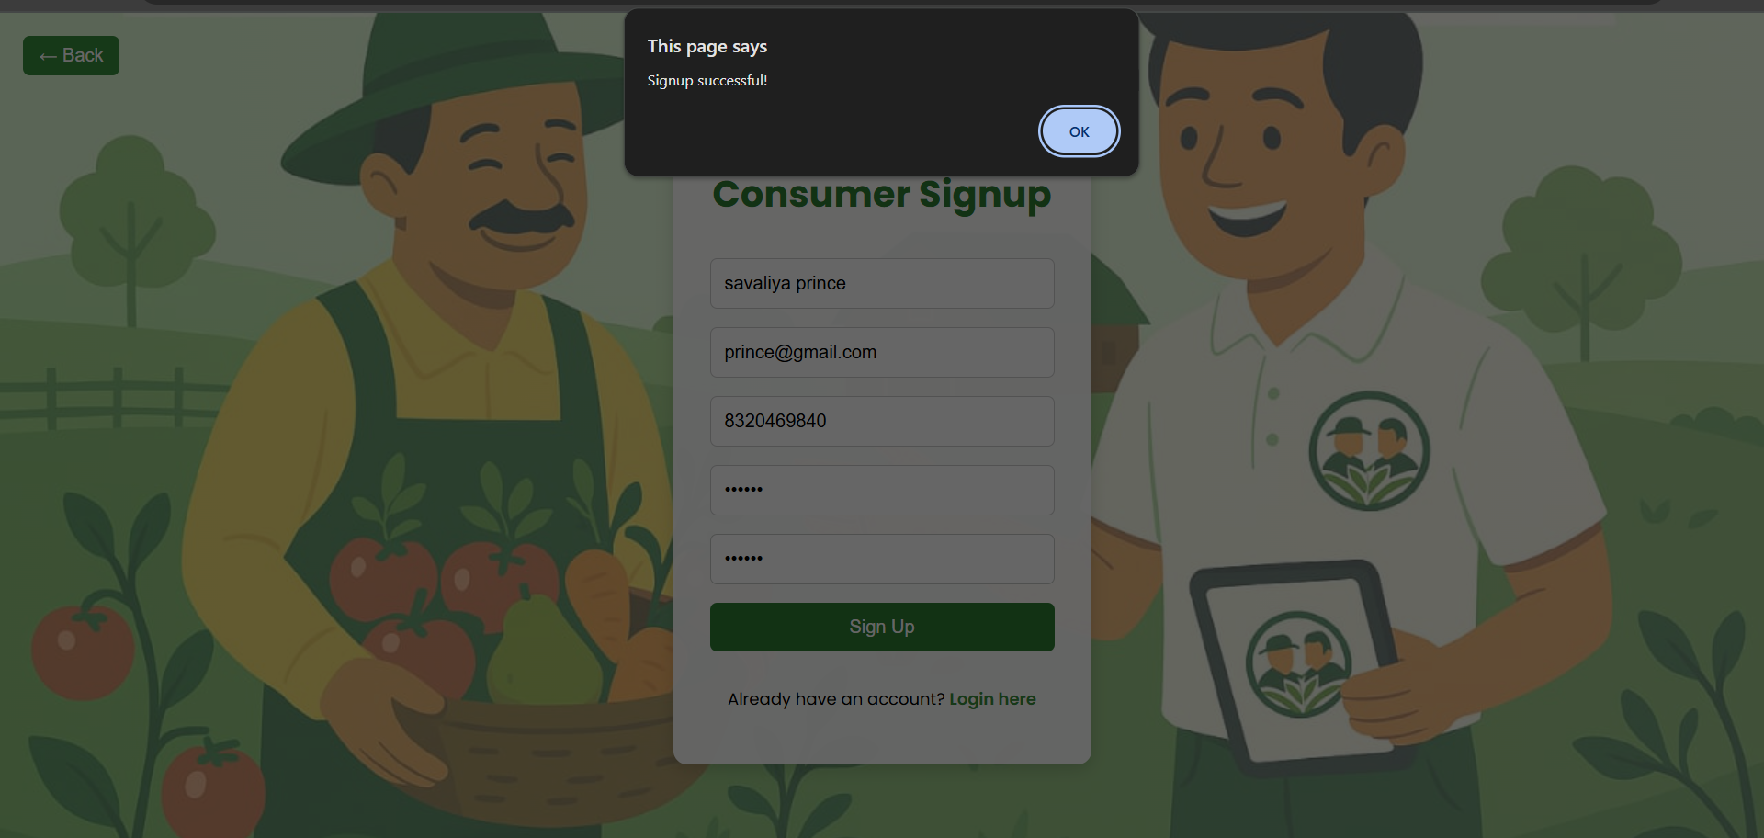



🡪 Welcome to the login page in our site.

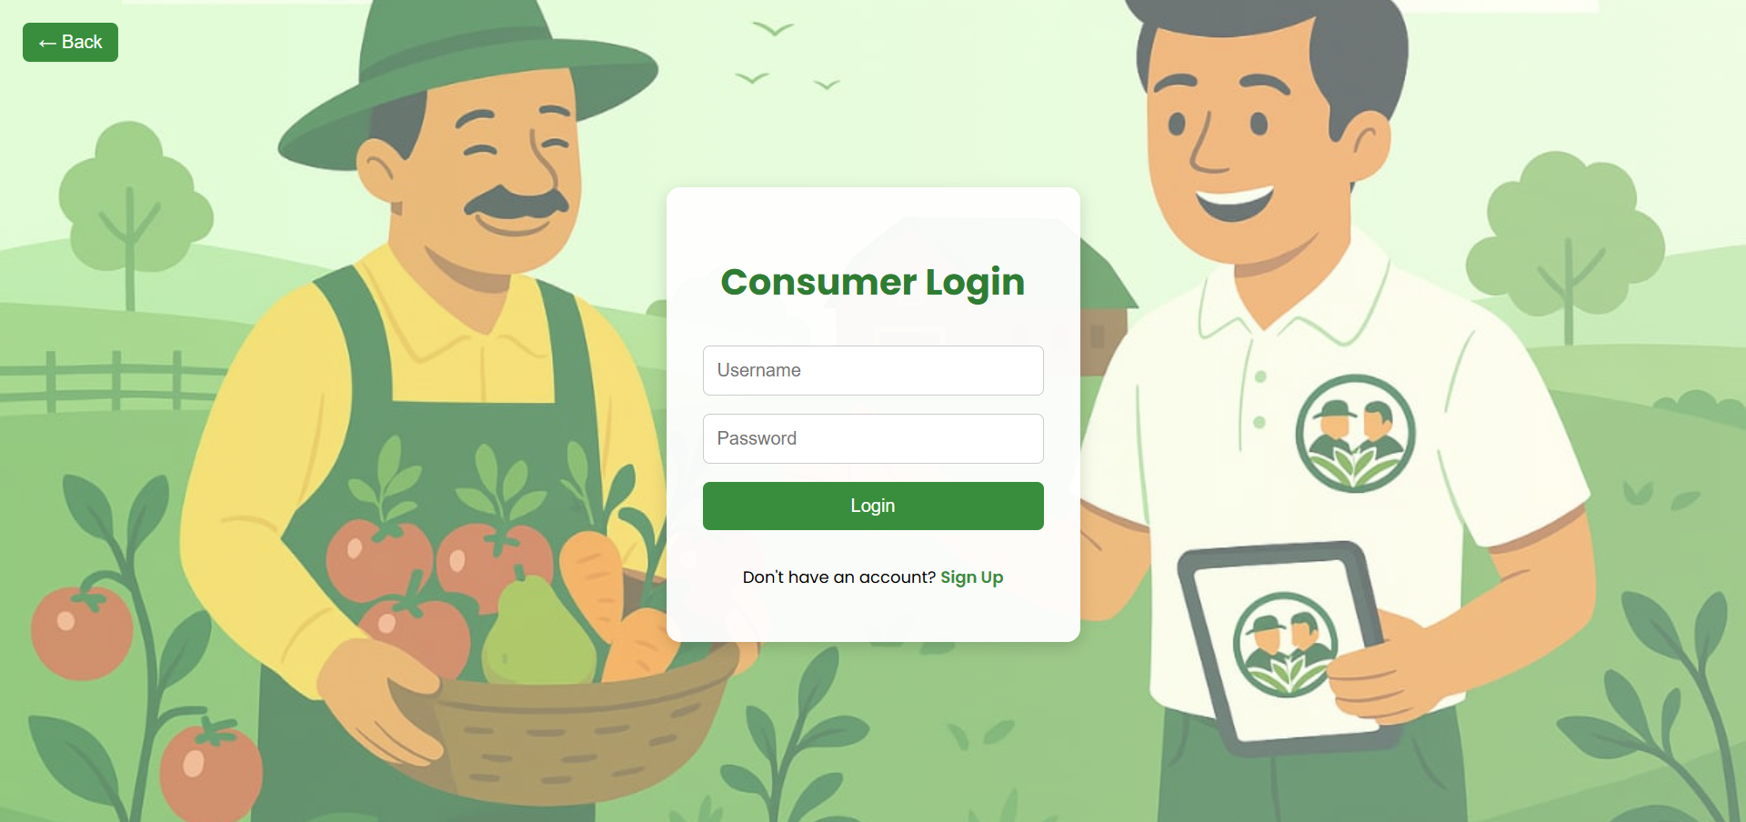



🡪 Enter the your username and password.

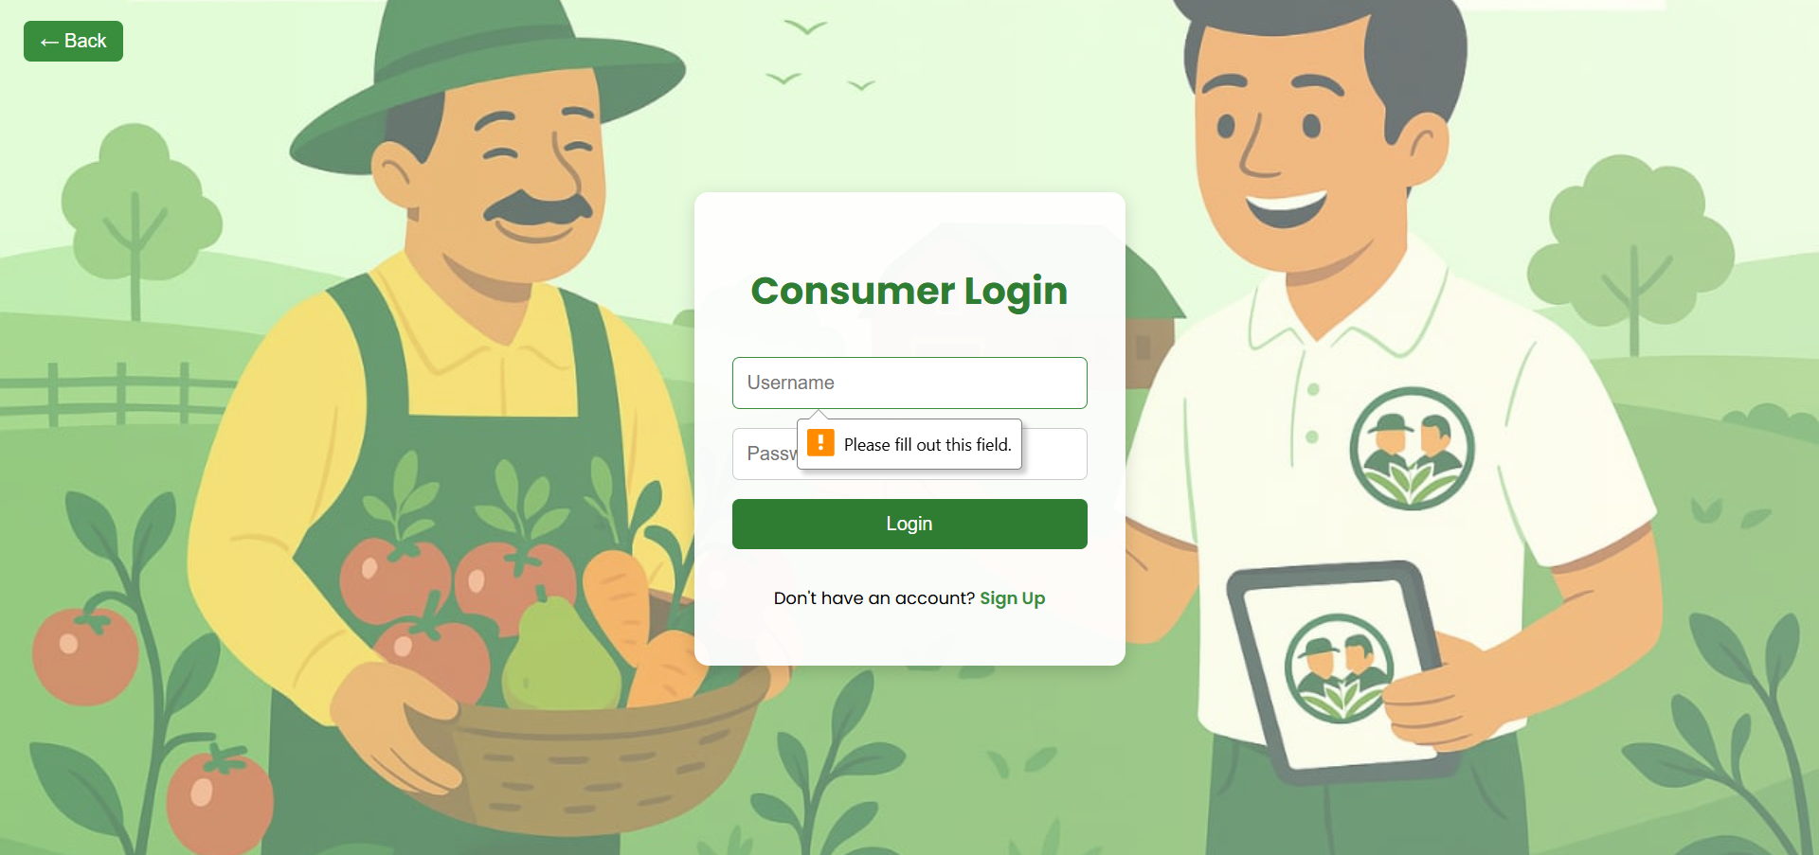



🡪 Fill up the consumer username and password.

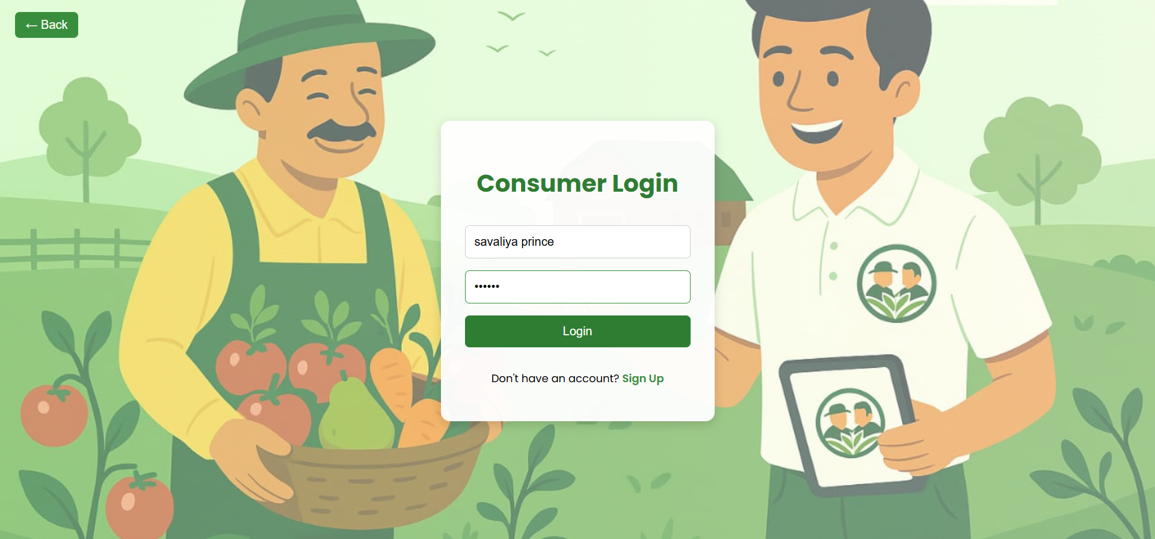



🡪





🡪 Click the button farmer then open sign up page.

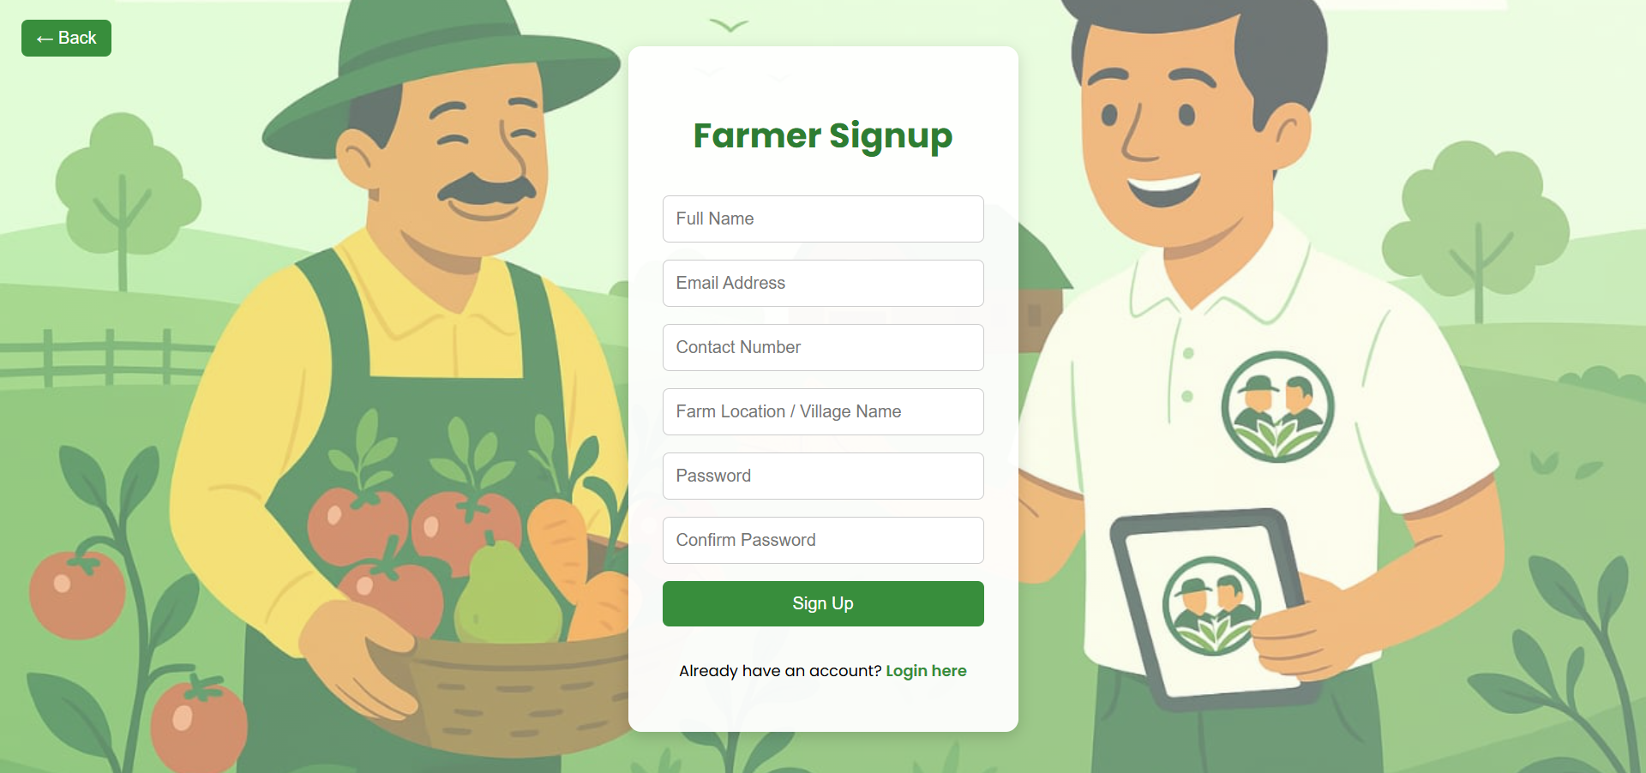



🡪 Fill this all details in farmer page then will sign up.

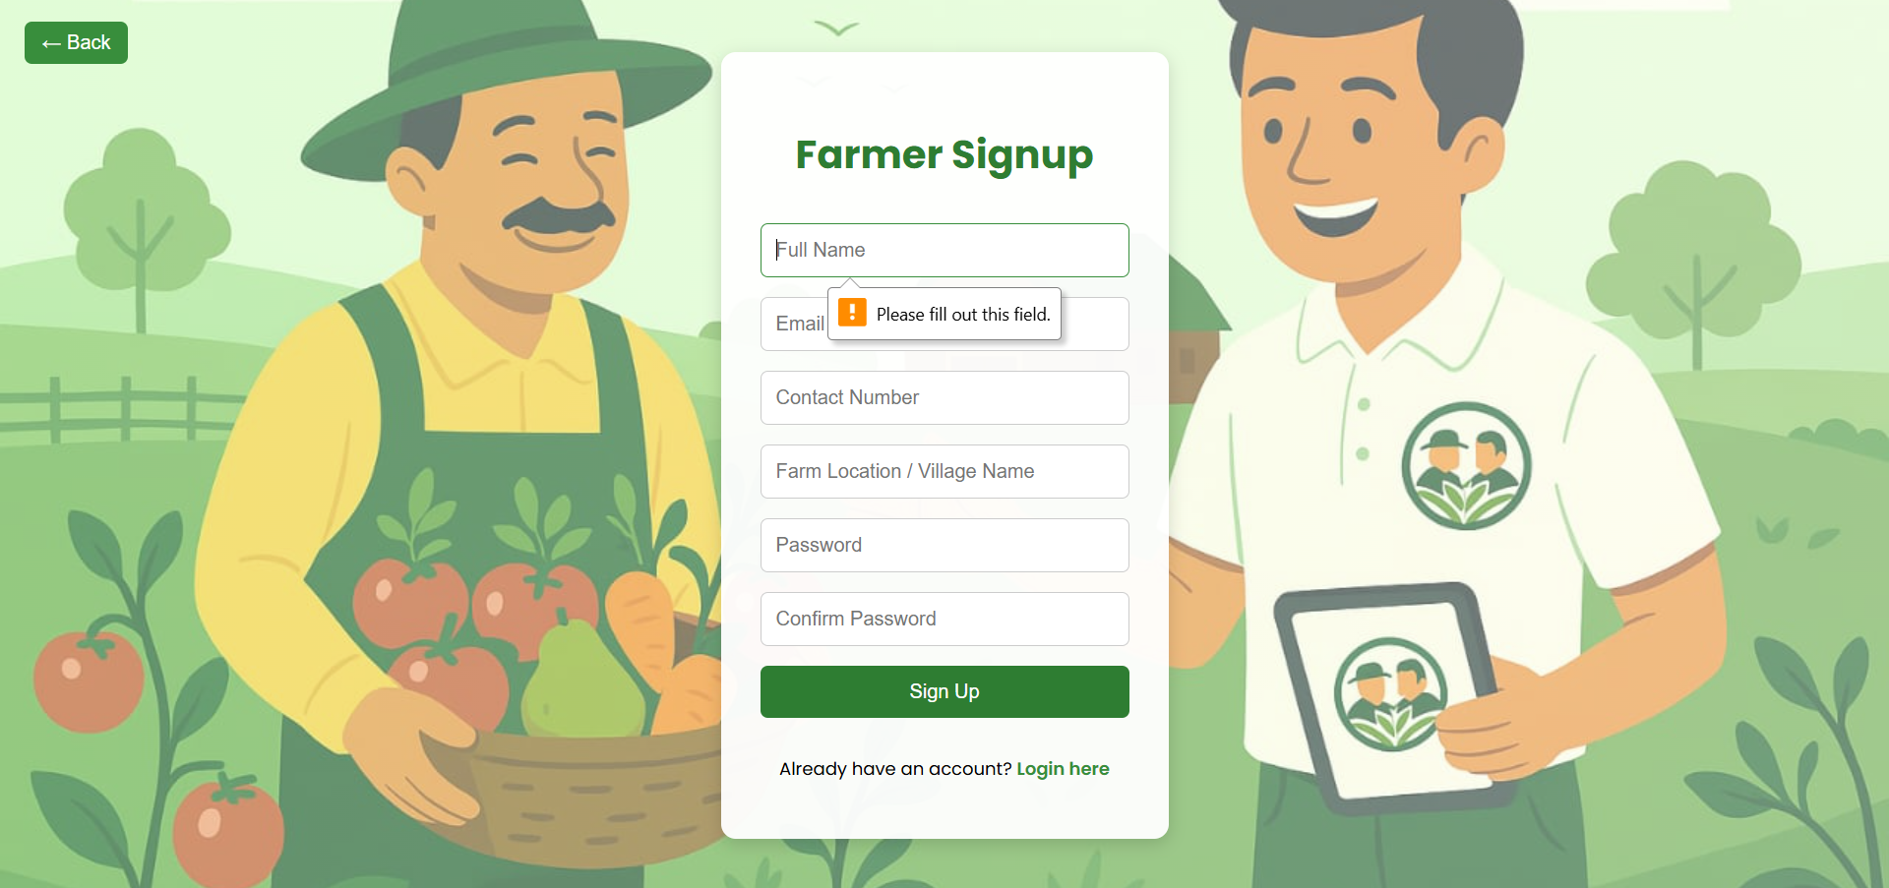



🡪 Fill up the details.

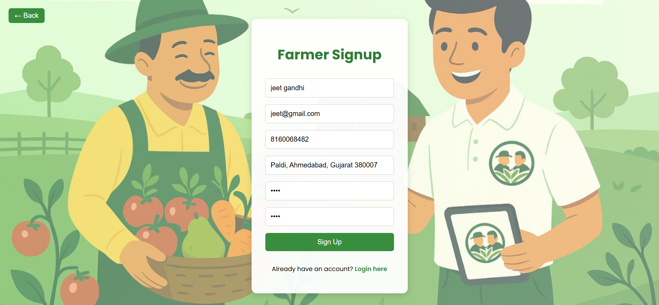



🡪 Fill up the all details then click sign up button.

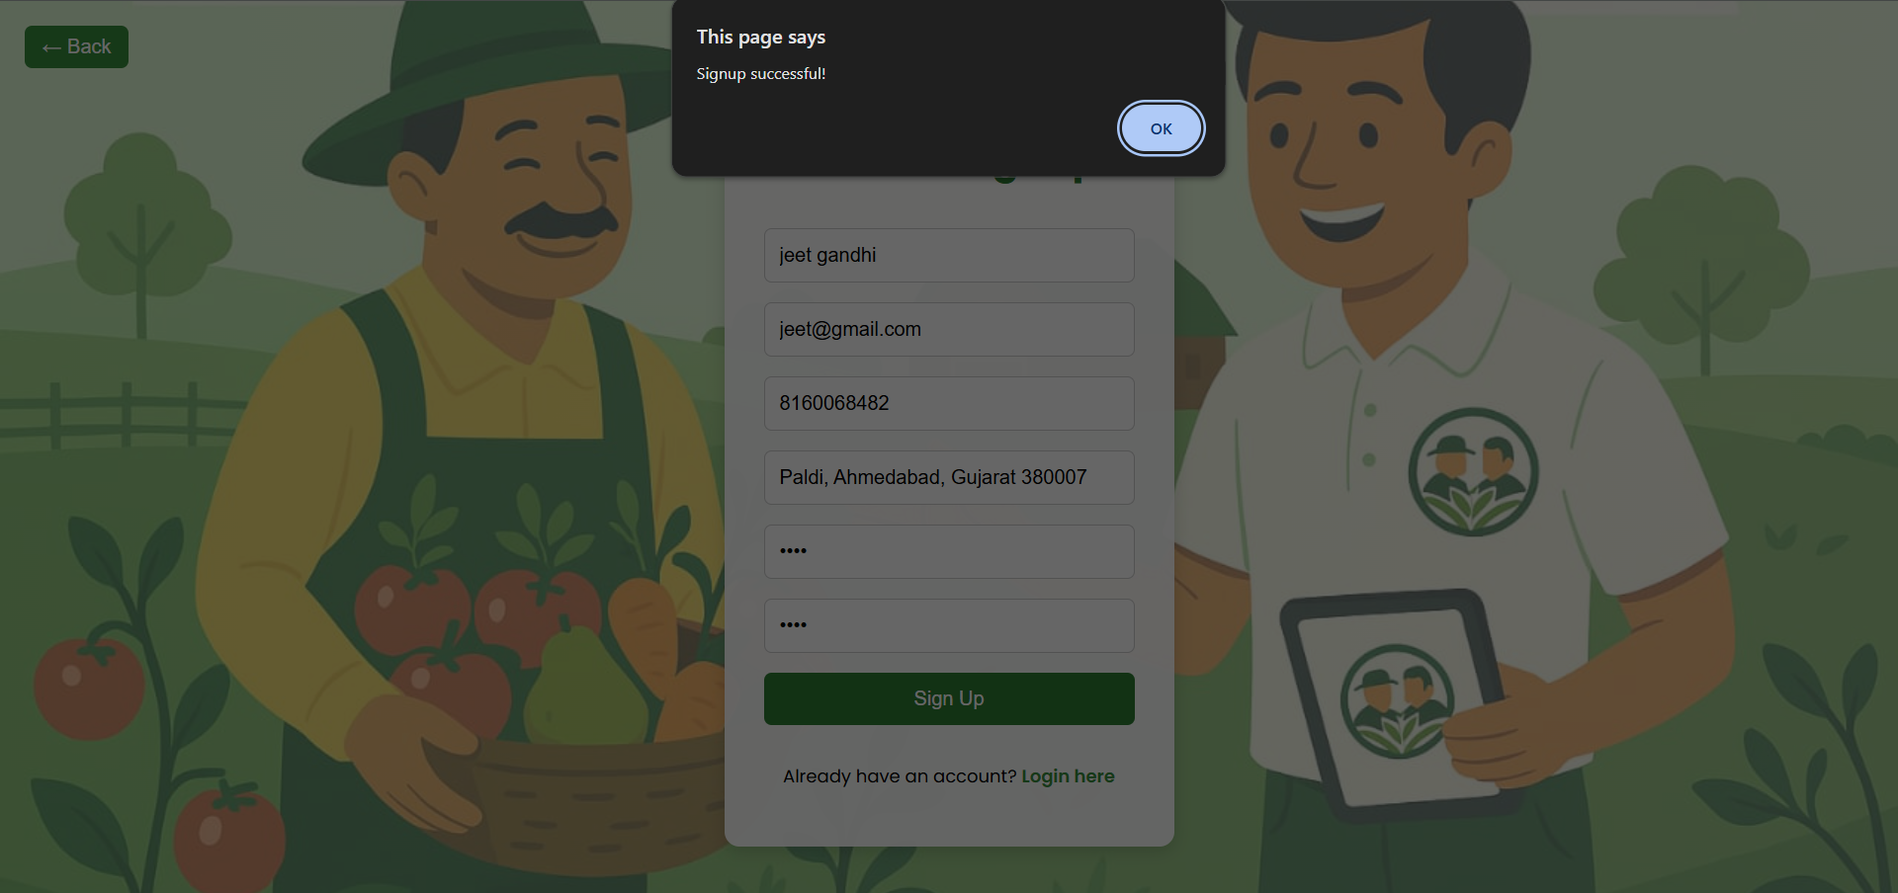



🡪 Welcome to the login page in our site.

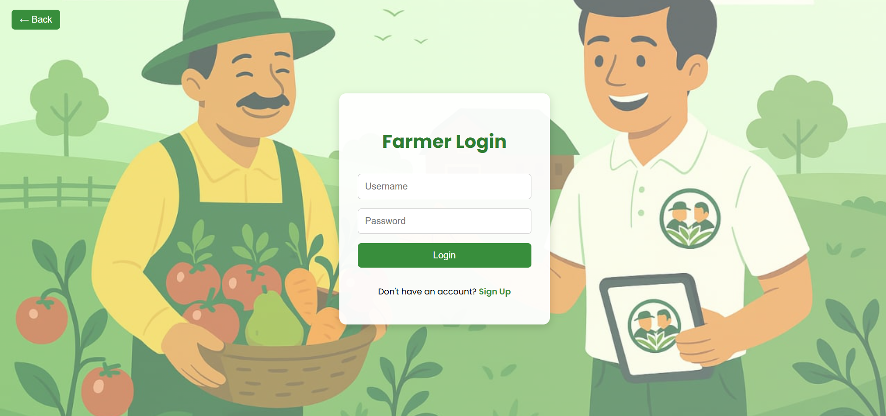



🡪 Enter the your username and password.

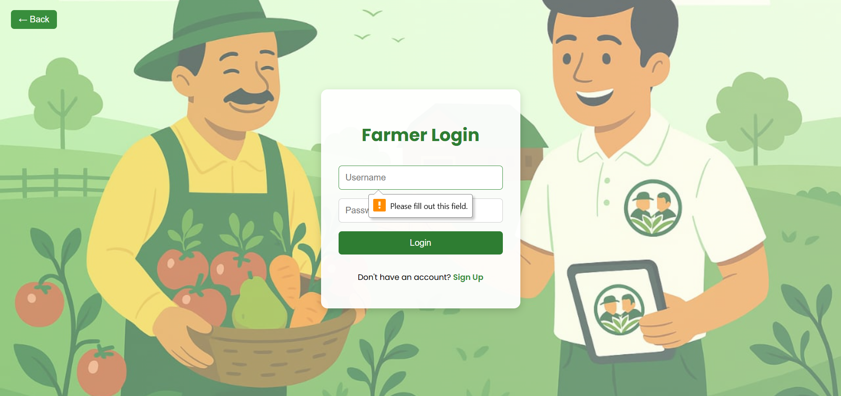



🡪 Fill up the farmer username and password.

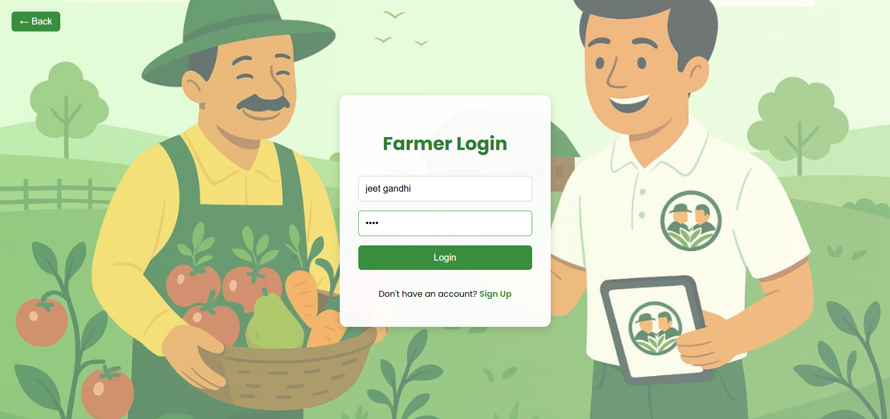



**Database Development**